Subject: Join Me in Supporting Local Artists – Let's Make an Impact Together!
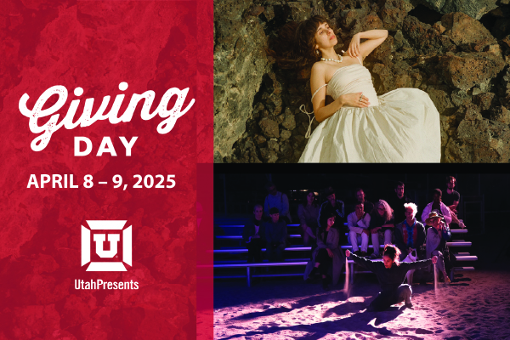
Hi [Friend's Name],
I’m reaching out with an exciting opportunity to support local artists right here in our community – and I need your help!
On U Giving Day, UtahPresents is raising funds for its Stage Door Series, a vital platform that promotes Utah-based artists. Your donation will directly benefit local creatives, including:
🎵 Little Moon – winners of the 2023 NPR Tiny Desk Contest with their stunning indie folk rock sound
💃 Stephanie Garcia – an internationally celebrated choreographer blending dance, video, and performance art
🎭 801 Salon – a multidisciplinary arts collective that brings dynamic pop-up performances to unique spaces across Salt Lake City
Your donation will also be doubled, thanks to a generous match from my fellow board members. $25 instantly becomes $50 and makes this series possible!
Here's the fun part: we have set up a friendly challenge to rally as many donations as I can – and I’d love for you to join me! Every gift, no matter the size, makes a difference.
Please consider donating today to help us support these amazing artists and keep Salt Lake’s creative community thriving. You can donate through here: utahpresents.org/give
Thanks so much for your generosity – and feel free to pass this along to anyone you know who’s passionate about the arts!
Best,
[Your Name]
Board Member, UtahPresents

